Load-Balancer-TASKS.
Mohammed Mujahed-16
1:Configure Classic Load balancer.
> Purpose of the Task
- To understand legacy AWS load balancing
- To distribute traffic across multiple EC2 instances
- To ensure high availability and fault tolerance
- To monitor instance health using health checks

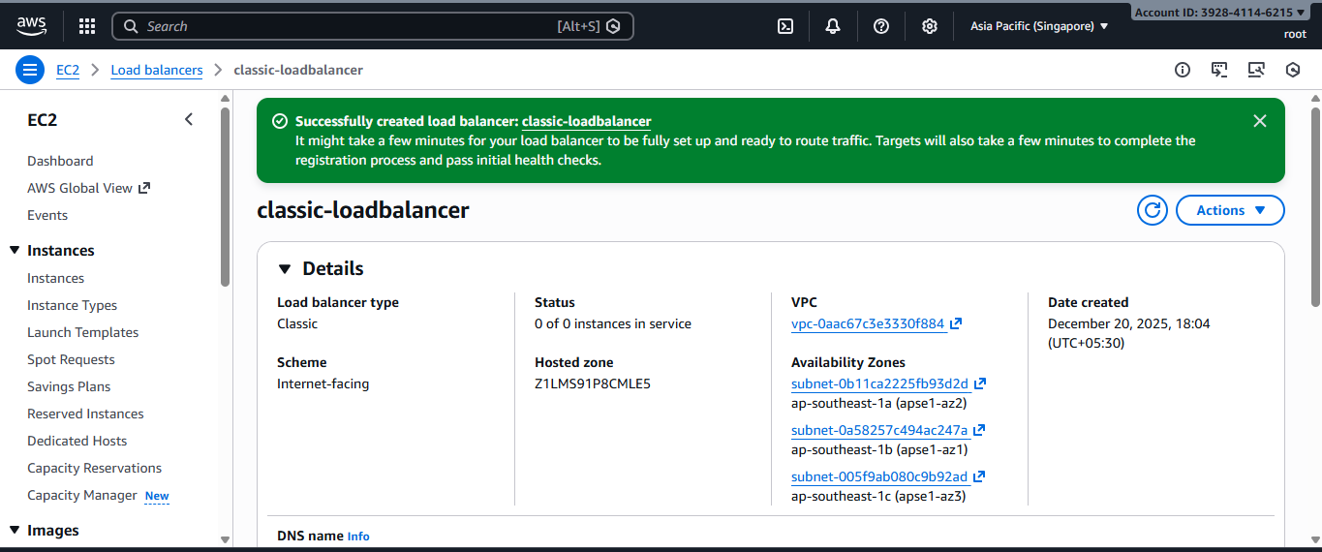
🔹 Steps
- Login to AWS Console → EC2 → Load Balancers
- Click Create Load Balancer
- Select Classic Load Balancer
- Provide:
  - Load Balancer Name
  - VPC
  - Availability Zones
- Configure Listeners:
  - HTTP : 80 → Instance : 80
- Select Security Group (allow port 80)
- Configure Health Check:
  - Ping Protocol: HTTP
  - Ping Path: /
- Add EC2 instances
- Create Load Balancer

2:Configure Application Load balancer.
🎯 Purpose of the Task
- To route traffic at Layer 7 (HTTP/HTTPS)
- To enable path-based and host-based routing
- To improve application scalability and performance
- To support modern microservices architecture

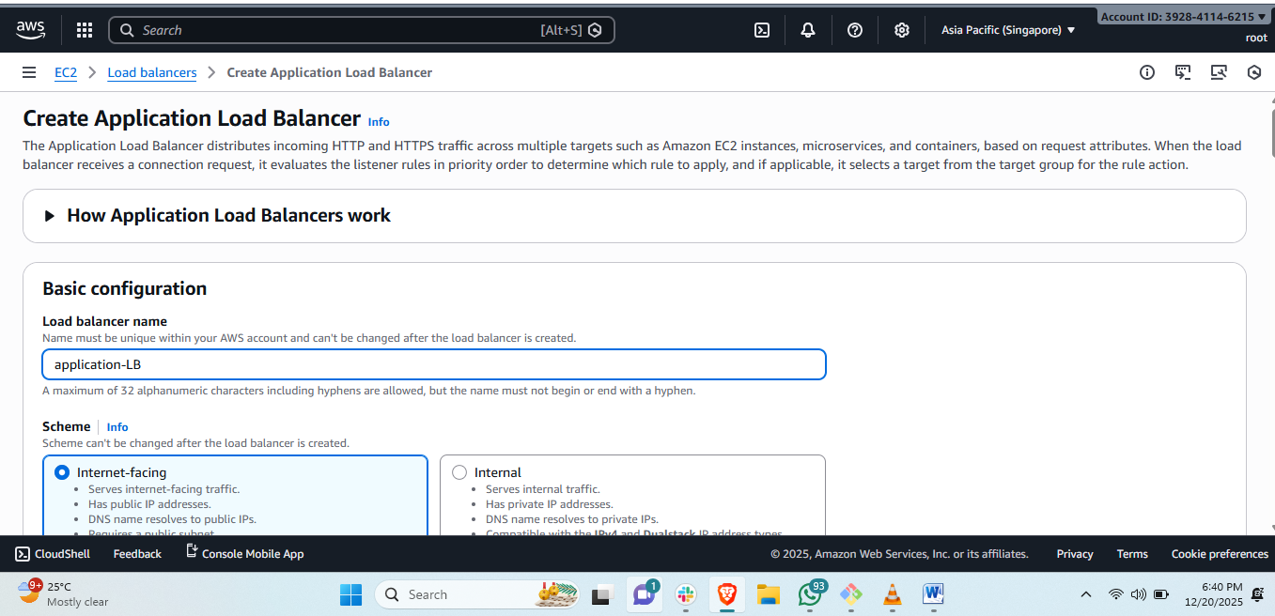
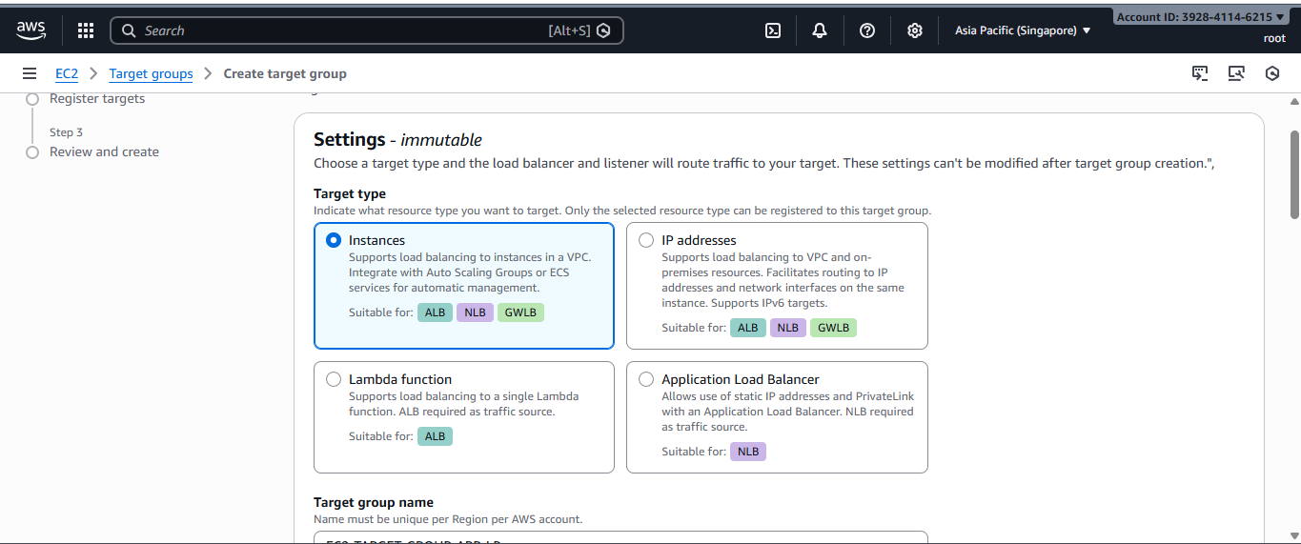
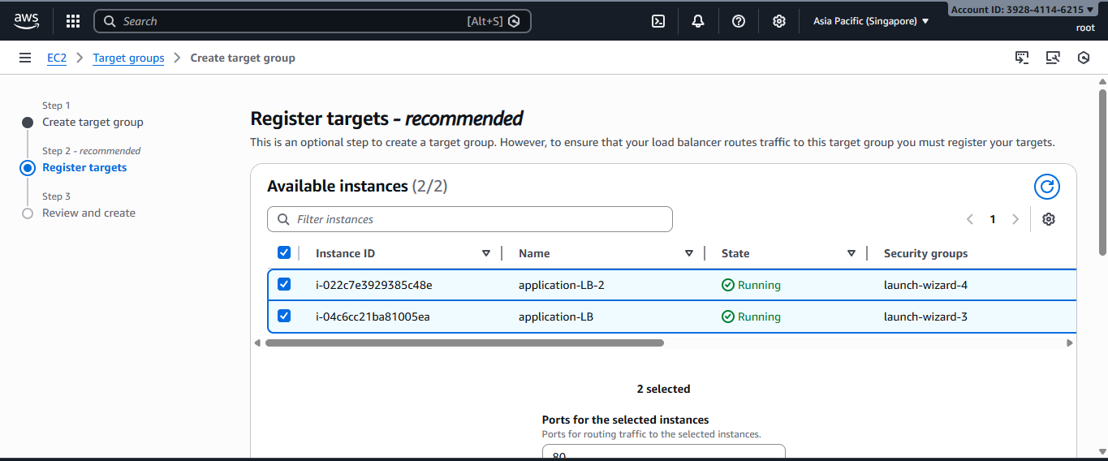
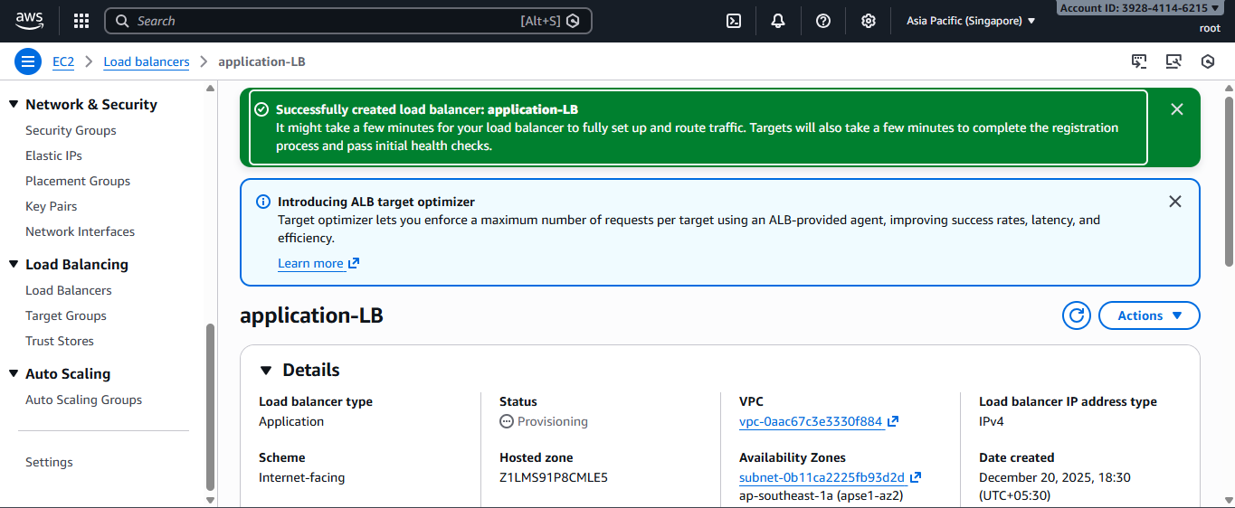
steps:
- EC2 → Load Balancers → Create Load Balancer
- Choose Application Load Balancer
- Configure:
  - Scheme: Internet-facing
  - IP type: IPv4
- Select VPC & Subnets
- Create Target Group:
  - Target type: Instance
  - Protocol: HTTP
  - Port: 80
- Register EC2 instances
- Configure Listener:
  - HTTP : 80 → Forward to Target Group
- Create ALB

3:Configure Network Load balancer.
🎯 Purpose of the Task
- To handle high-performance, low-latency traffic
- To operate at Layer 4 (TCP/UDP)
- To support applications requiring static IP addresses
- To efficiently manage millions of requests per second.
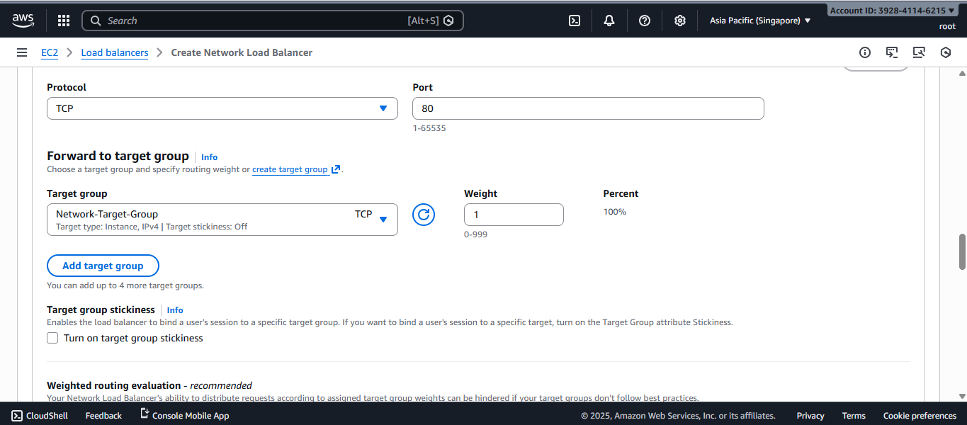
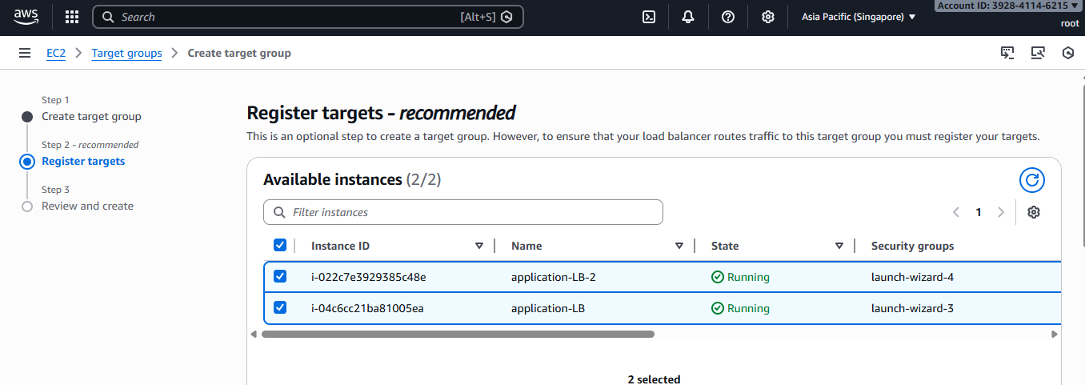
🔹 Steps
- EC2 → Load Balancers → Create Load Balancer
- Select Network Load Balancer
- Configure:
  - Scheme: Internet-facing
  - IP type: IPv4
- Create Target Group:
  - Protocol: TCP
  - Port: 80
- Register EC2 instances
- Create NLB

4:Attach SSL for application load balancer.
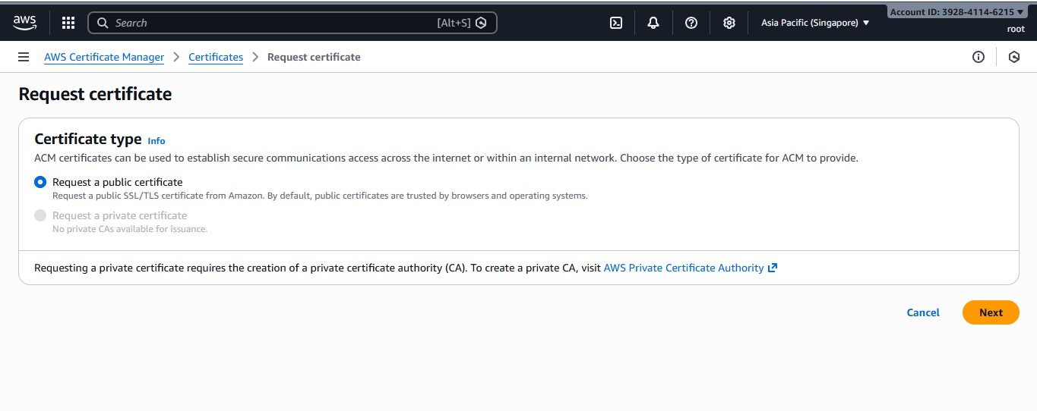

5:Map Application load balancer to R53.
> Purpose of the Task
- To map a custom domain name to ALB
- To simplify access using user-friendly URLs
- To enable AWS-managed DNS routing
- To ensure reliable and scalable domain resolution

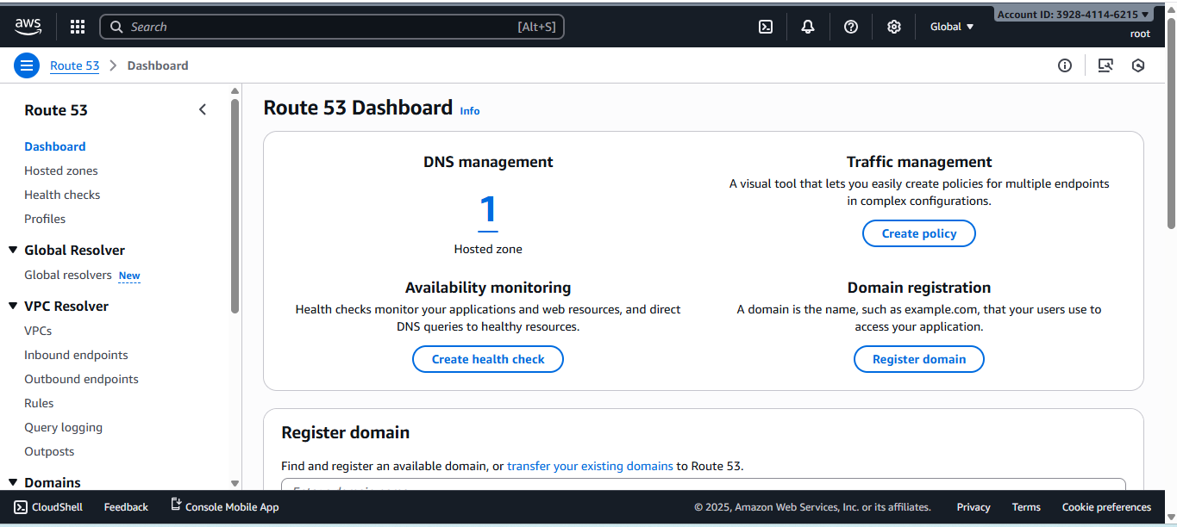
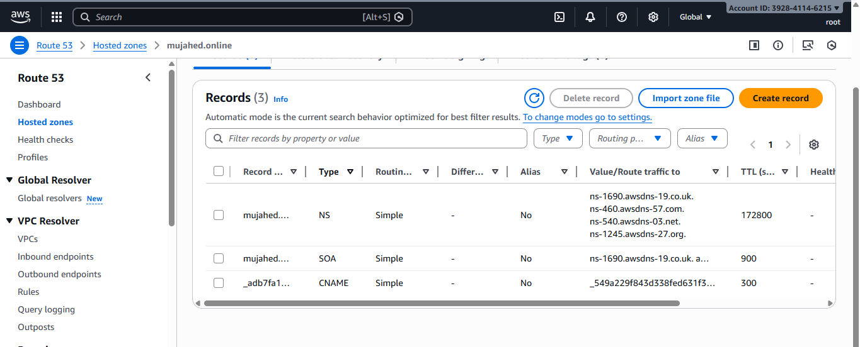
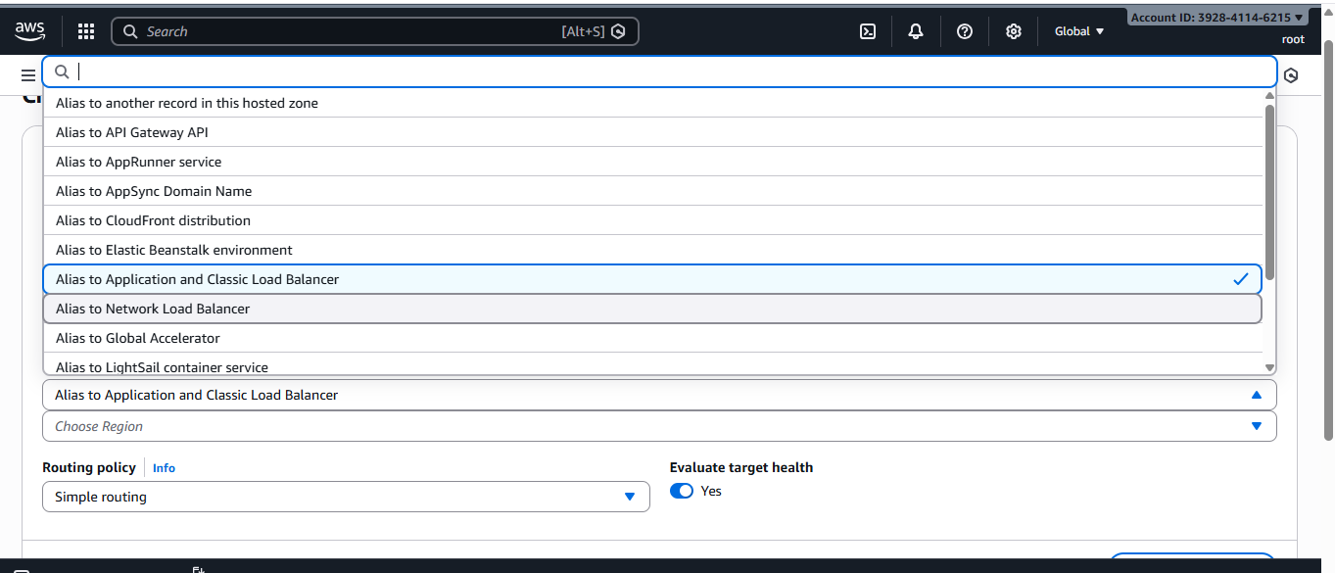
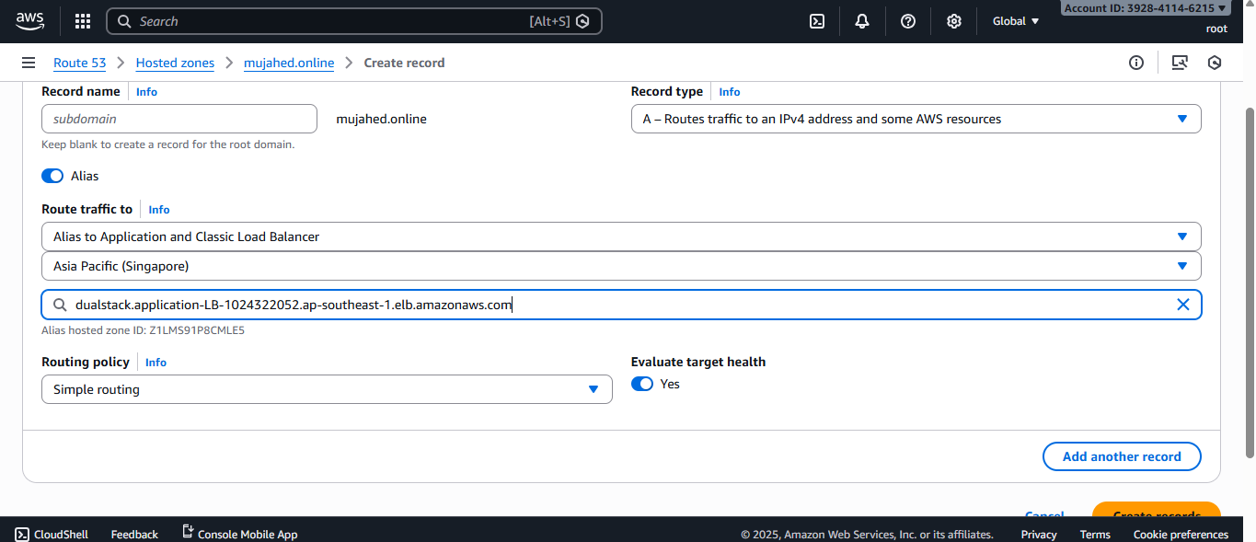
🔹 Steps
- Go to Route 53 → Hosted Zones
- Select the domain
- Create Record
- Record type: A – Alias
- Alias target: Application Load Balancer
- Save the record

6:Push the application load balancer logs to S3.

> Purpose of the Task
- To capture request and response logs
- To monitor traffic patterns
- To assist in debugging and troubleshooting
To meet auditing and compliance requirements
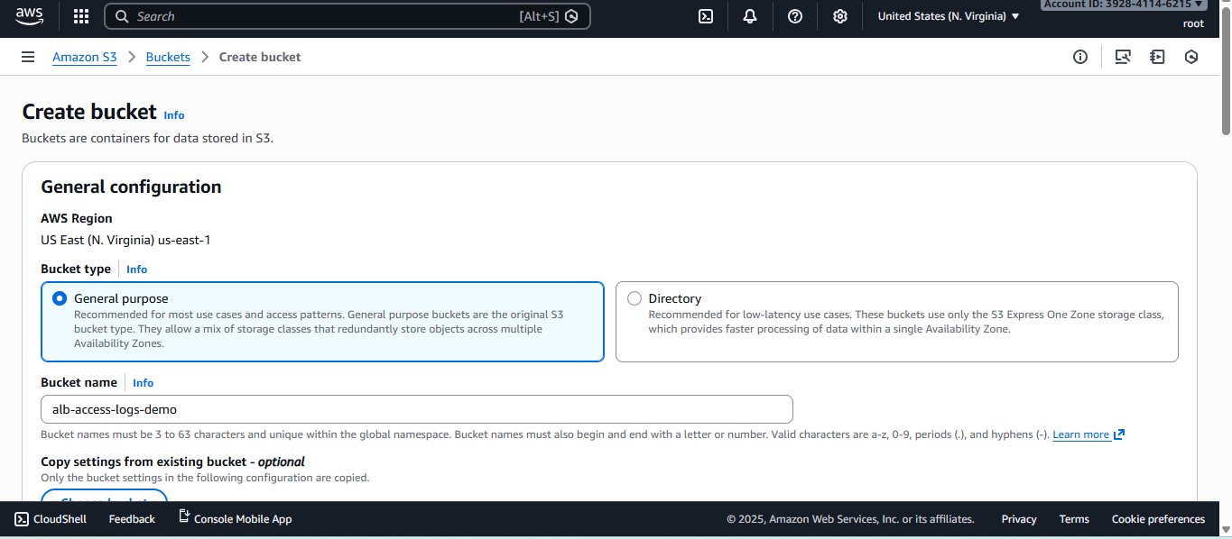
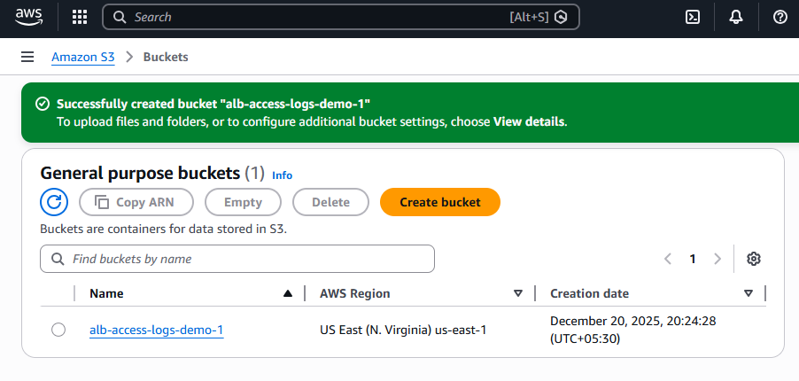
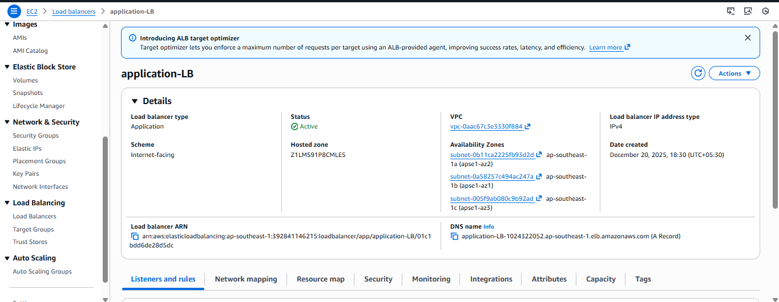
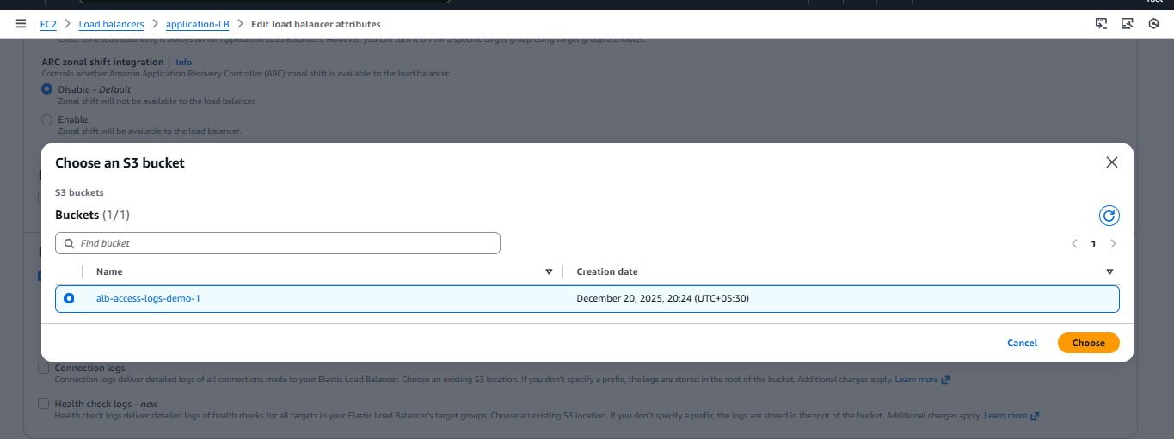
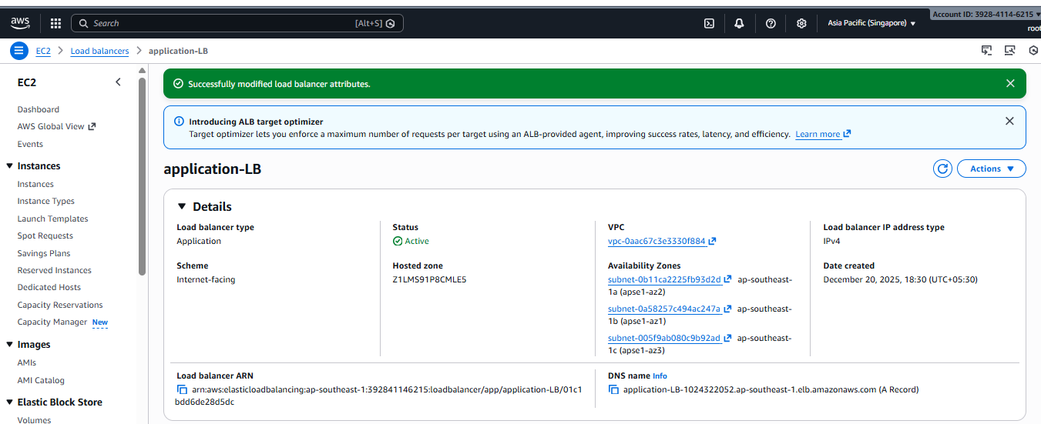
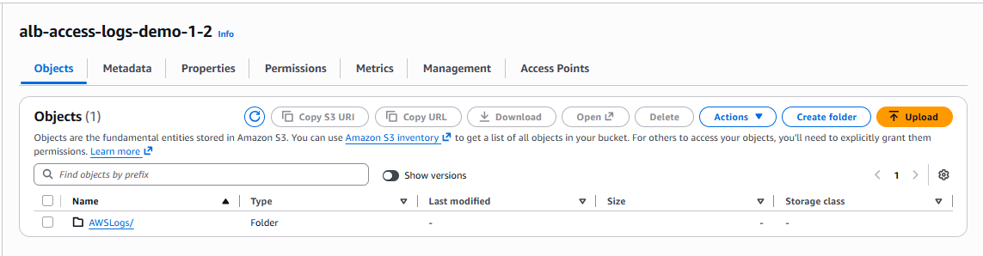
steps: • Create an S3 bucket
- Example: alb-access-logs-demo
• Apply bucket policy to allow ALB access
• Go to ALB → Attributes
• Enable Access Logs
• Select the S3 bucket
• Save changes
• Generate traffic to ALB
• Verify logs in S3 bucket

